**Esg research in municipal bonds:**

**Explainability of Outcome**

**Industry project with Blackrock**

**Pankaj Kumar**

**(MFE Student at Haas School of Business)**

**Email-id: pankaj_kumar@berkeley.edu**

Objective:

In this Industry Project, we attempt to answer the fundamental question on the effect of Green Labeling on bond analytics. Does Green label securities drive the expected financial/societal outcome? Our main objective is to explore insights that drive sustainable outcomes in the municipal bond market from an environmental perspective. To answer this question, we collected Green Bond data that is relevant to Munis using Bloomberg and ICE BofA US Municipal Securities. For this, we see the bonds at the security, state, issuer levels.

We divide the issuer into Green and Non-Green. We check how green and non-green bonds perform from the same Green Issuer.

Introduction:

**Overview:**

Municipal bonds are fixed income securities issued by states, cities, counties and other governmental entities to raise money to build roads, schools and a host of other projects for the public good. Term-wise, Muni bonds have maturities that range from short term (2 – 5 years) to very long term (30 years).

Foreign Investor holdings of US municipal bonds surpassed USD 100 bn for the first time at the end of 2017. The higher yield and strong credit profile of municipal bond issuers attracted foreign investments. Please see below charts for the same

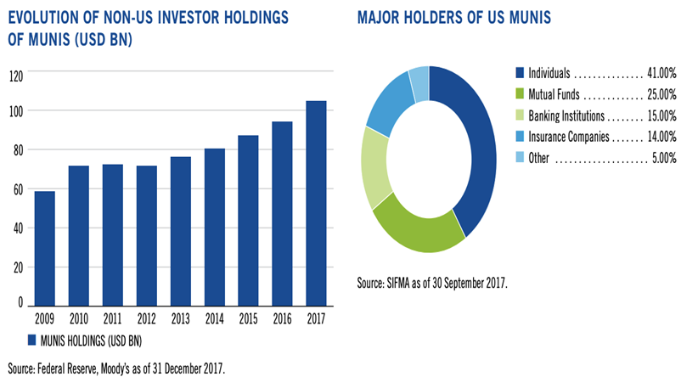

**Characteristics of Bonds:**

**Liquidity:** Municipal bonds tend to be less sensitive to forces of supply and demand than other fixed-income categories as investors prefer to buy and hold this asset class.

**Munis and Taxes:** Most individual investors buy municipal bonds is because they afford favorable tax treatment on the interest an investor earns. Interest on the vast majority of municipal bonds is free of income tax.

**ATTRACTIVE YIELDS VERSUS EUROPEAN GOVERNMENT, CORPORATE DEBT**

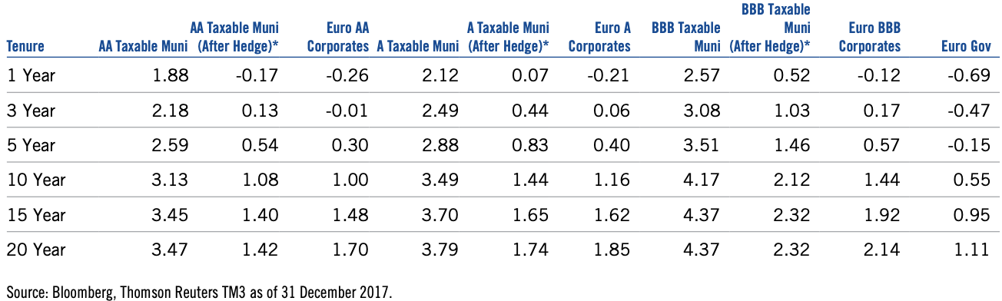

**AVERAGE FINAL MATURITY AT ISSUANCE (YEARS)**

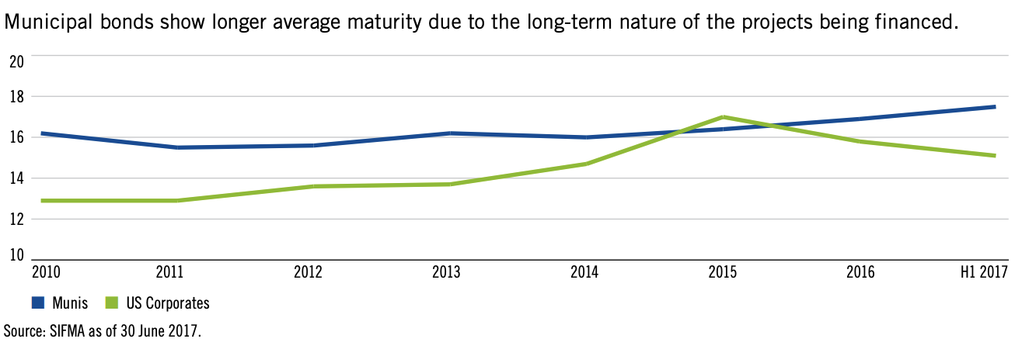

**CREDIT PROFILE OF MUNICIPAL BONDS**

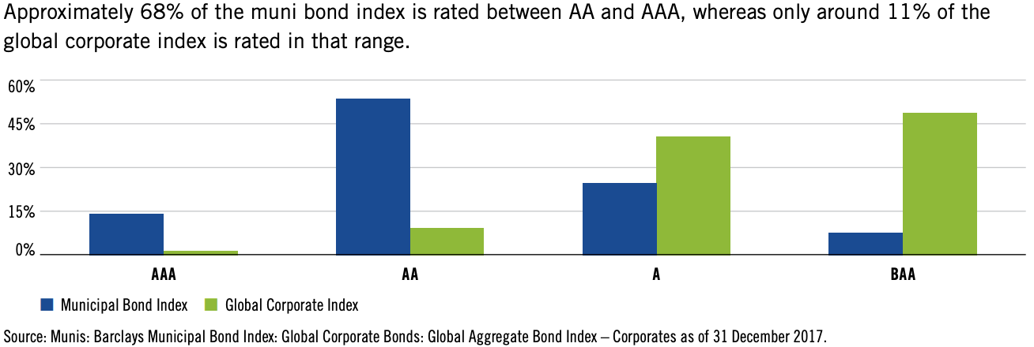

**MUNICIPAL BOND CORRELATIONS WITH VARIOUS ASSET CLASSES**

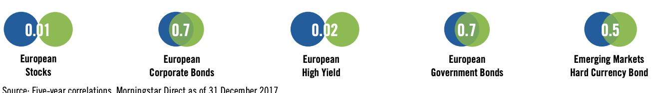

**Categorization of Muni Bonds:**

**General Obligation (GO) Bonds:** These bonds are issued by municipalities are backed by the full faith and credit of the issuer. Issuer can make interest and principal payments using any source of revenue available to them, such as tax revenues, fees, or the issuance of new securities. This means that if the municipality encounters fiscal difficulty, it can raise taxes to offset the shortfall.

**Revenue Bonds:** These bonds are issued by municipalities and fund projects; they are backed by the revenues the projects bring in. In other words, the money raised by the bond offering directly finances the project, and the project—once complete—generates the revenues to pay back the interest and principal on the bonds to investors. Revenue bonds are generally of higher risk than general obligation bonds, and as a result, they typically offer higher yields.

**Other Type of Bonds:**

* **Anticipation Notes**
* **Pre-refunded bonds**
* **Insured bonds**

Revenue municipal bonds account for nearly two-thirds of all investment-grade muni’s outstanding, but they tend to get less attention than their more popular general obligation bonds.

**Green Bonds in Muni Market:**

Climate change is considered a pressing global issue. Among the multiple initiatives to combat climate change by lowering the carbon footprint, emerge a niche segment dubbed as the green bonds. Green bonds are fixed-income securities issued by countries, Institutions and corporates. The proceeds are committed to finance environmental and climate-friendly undertakings, such as renewable energy projects, green buildings.

* Green bonds are a segment of the wider umbrella of sustainable bonds, which includes social and sustainability bonds as well. World’s first ever green bond was issued back in 2007 by the European Investment Bank (EIB) under the label of Climate Awareness Bond (CAB).
* This was followed by the World Bank issuing its first green bond in 2008 in partnership with SEB.
* In March 2013, International Finance Corporation (IFC) issued a $1 billion green bond to support IFC climate-friendly projects in developing countries.
* According to a report by Moody’s, sustainable bond issuance (green, social and sustainability) may top $650 billion in 2021, representing a growth of 32% over the previous year. The issuance of green bonds is estimated at $375 billion, while the remaining is split between social and sustainability bonds.

source: https://www.nasdaq.com/articles/green-bonds-on-the-rise-2021-07-02

DATA

**ICE BofA US Municipal Securities Index**

This index tracks the performance of US dollar denominated investment grade tax-exempt debt publicly issued by US states and territories, and their political subdivisions, in the US domestic market.

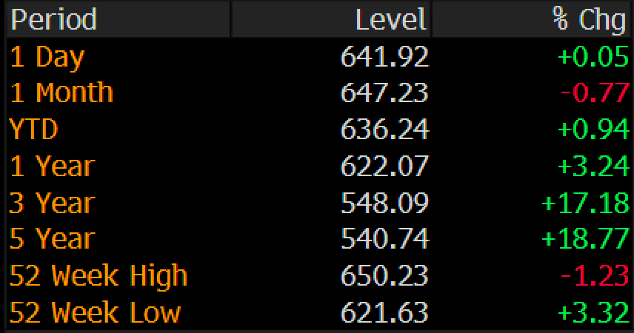

**Basic Analysis:**

ICE Index Snapshot:

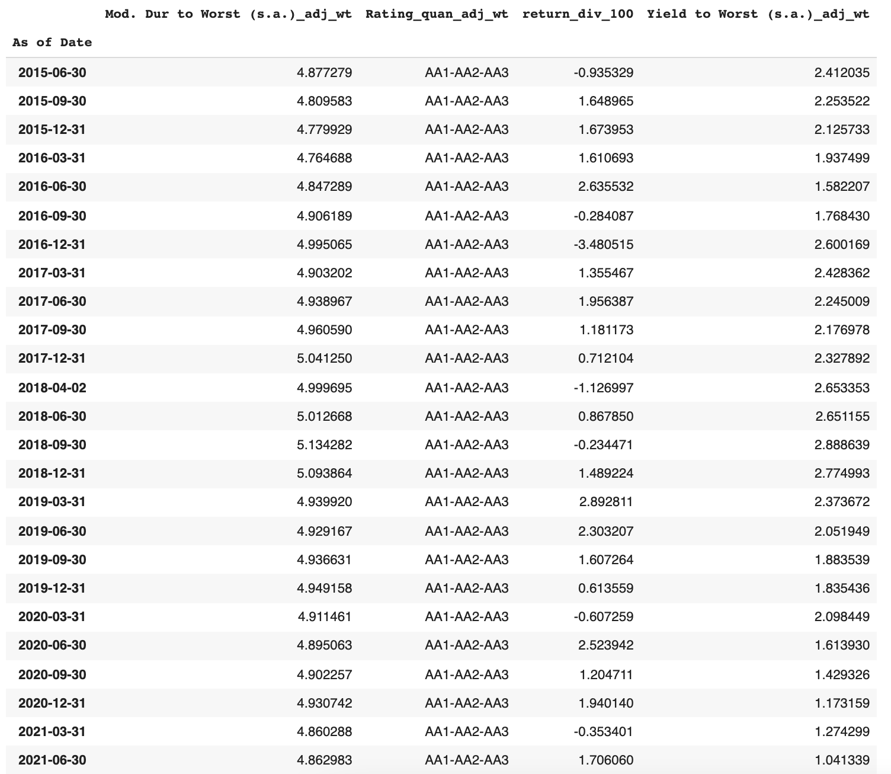

Green Bond Snapshot:

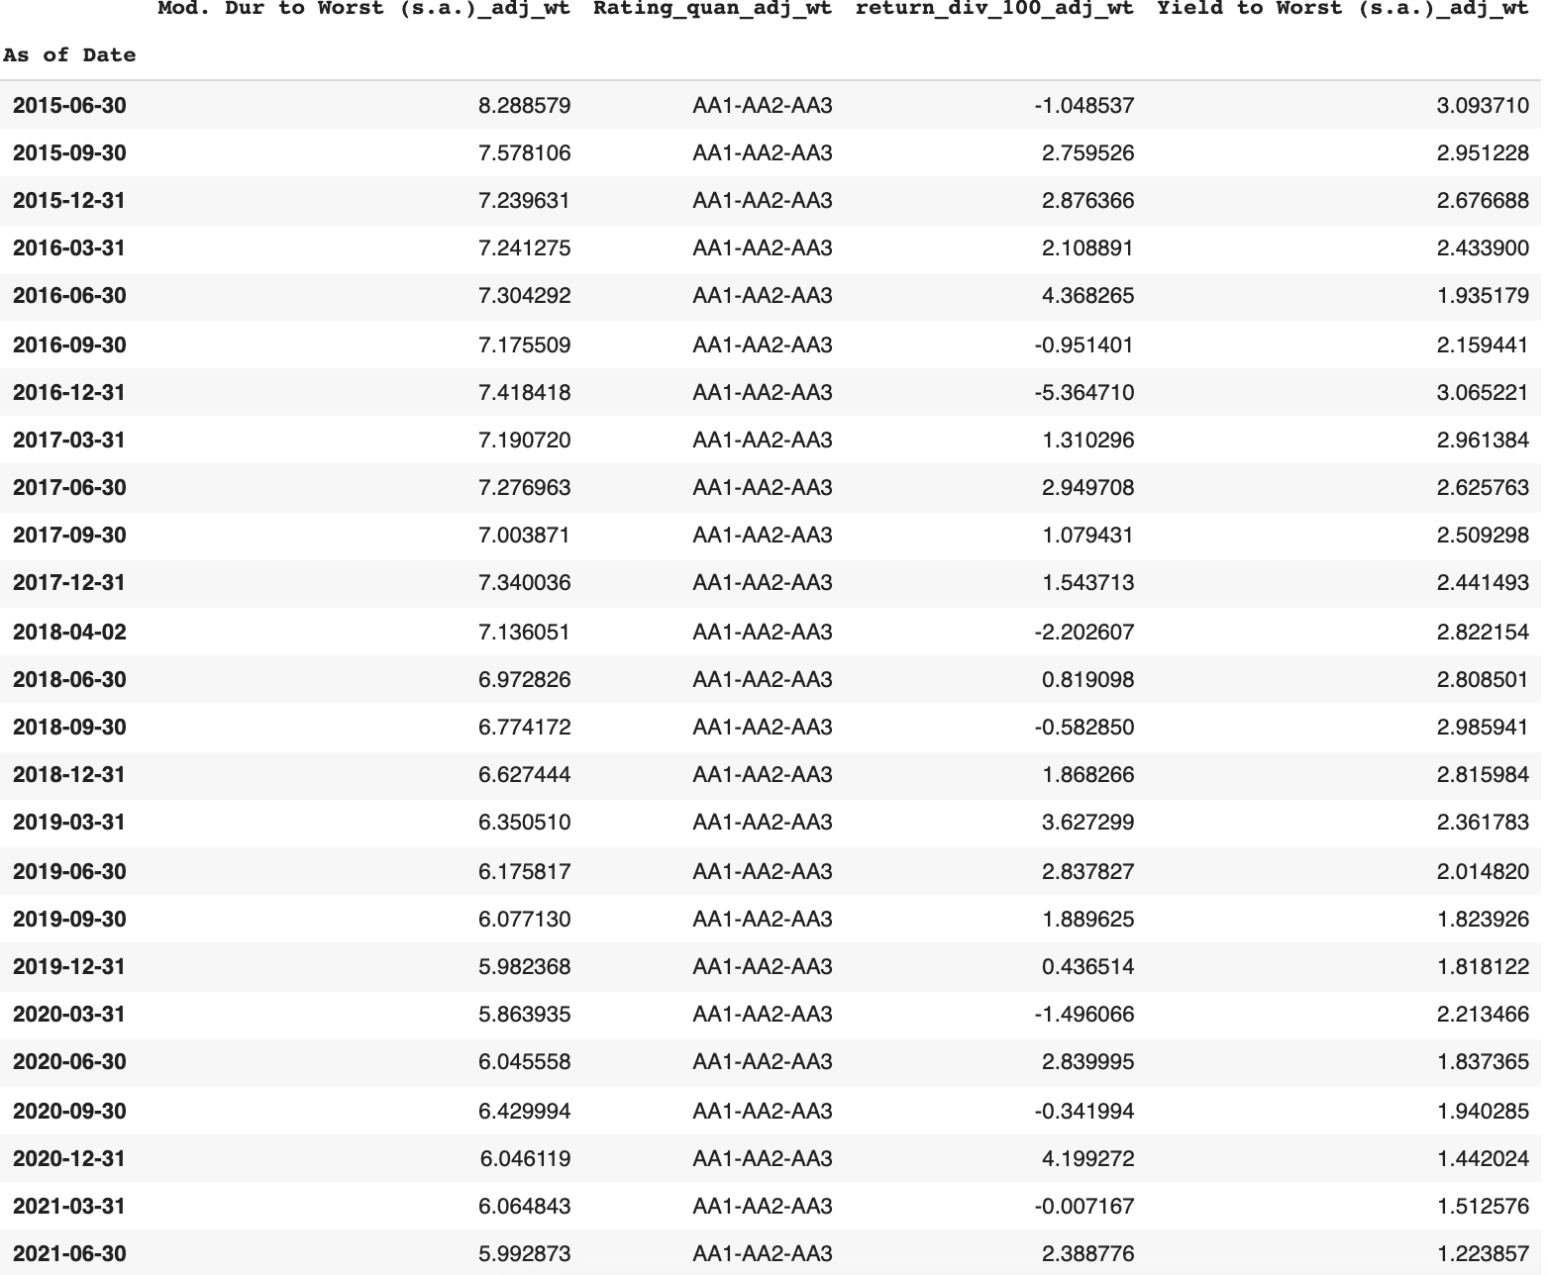

**Bond Coverage:**

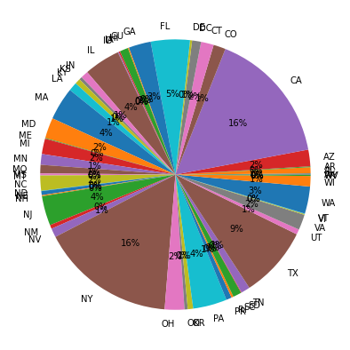 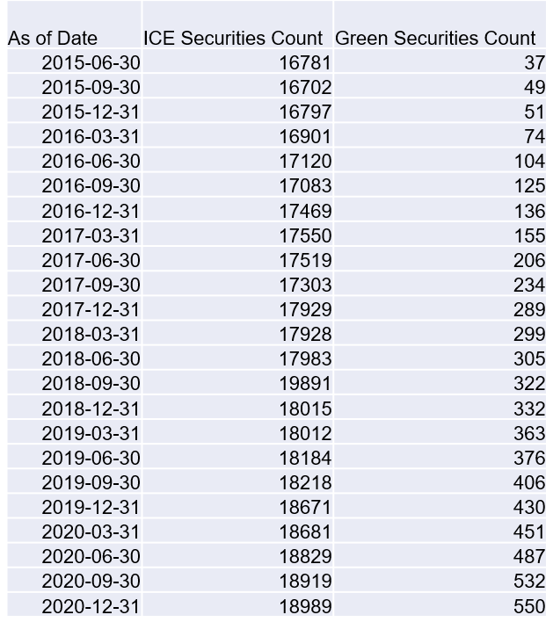

Figure : Three main states from the Index:

California, New York and Texas

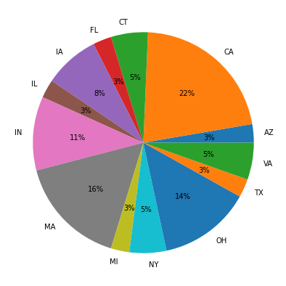 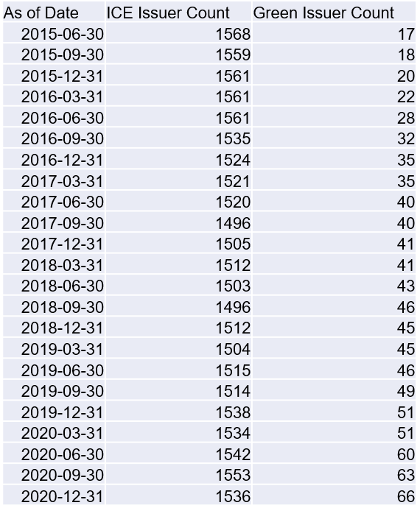

Figure : Three main states which issue green bonds are:

California, Massachusetts and Ohio

**Green Bond in Index**

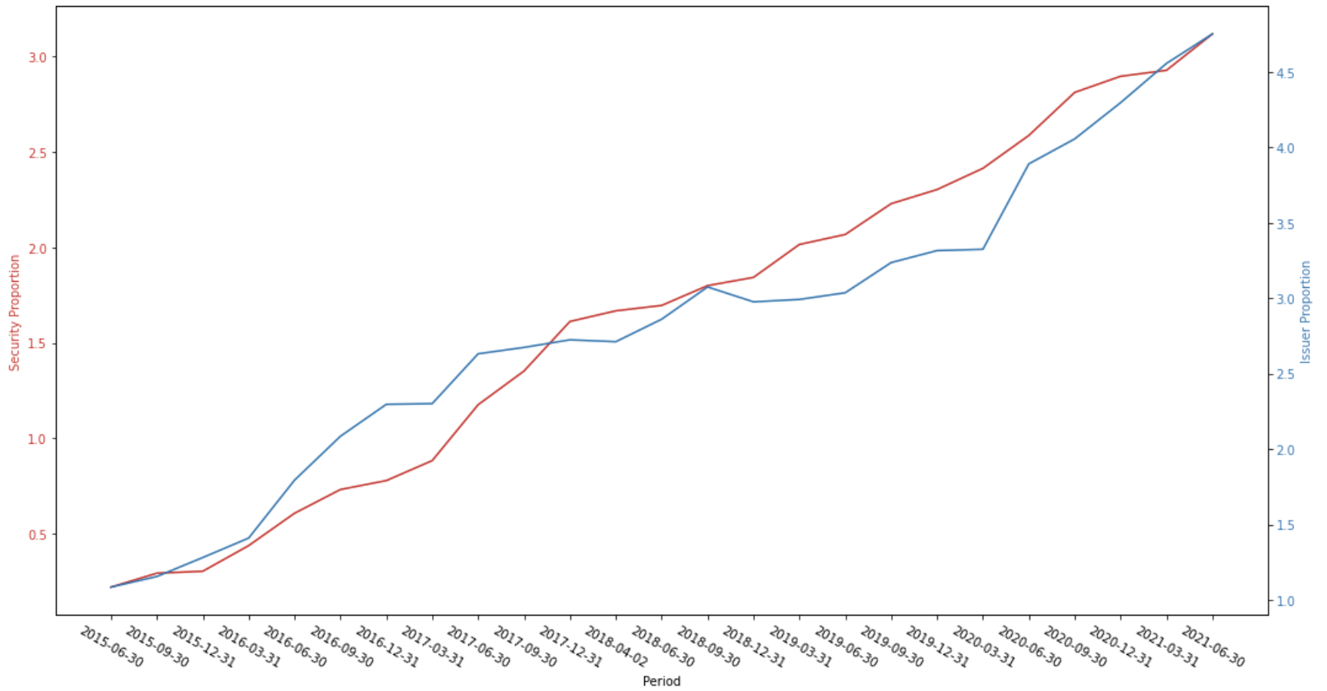

Figure : Green Bonds Issuers count shows more % increase in count of securities.

Green Bonds show an increasing trend in both count of securities and Issuer count

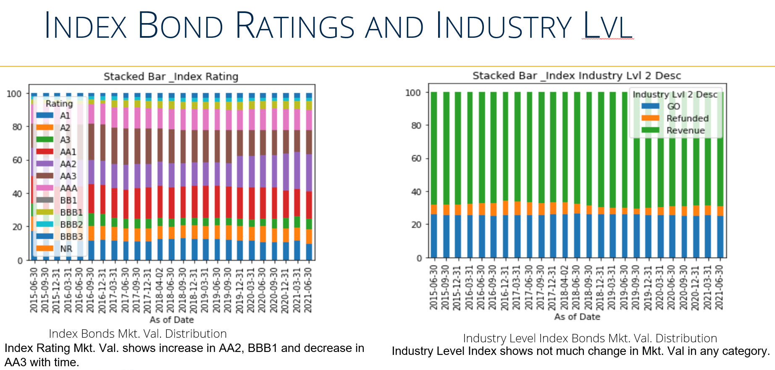

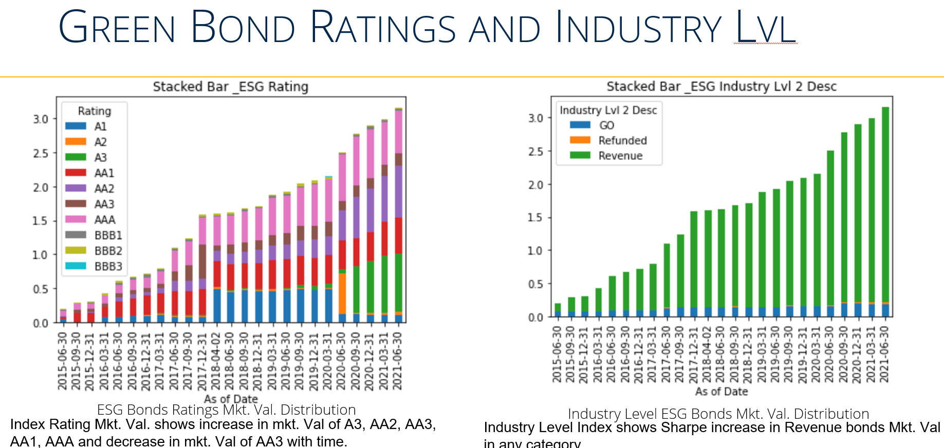

**Returns**

Index Cumulative Total Returns

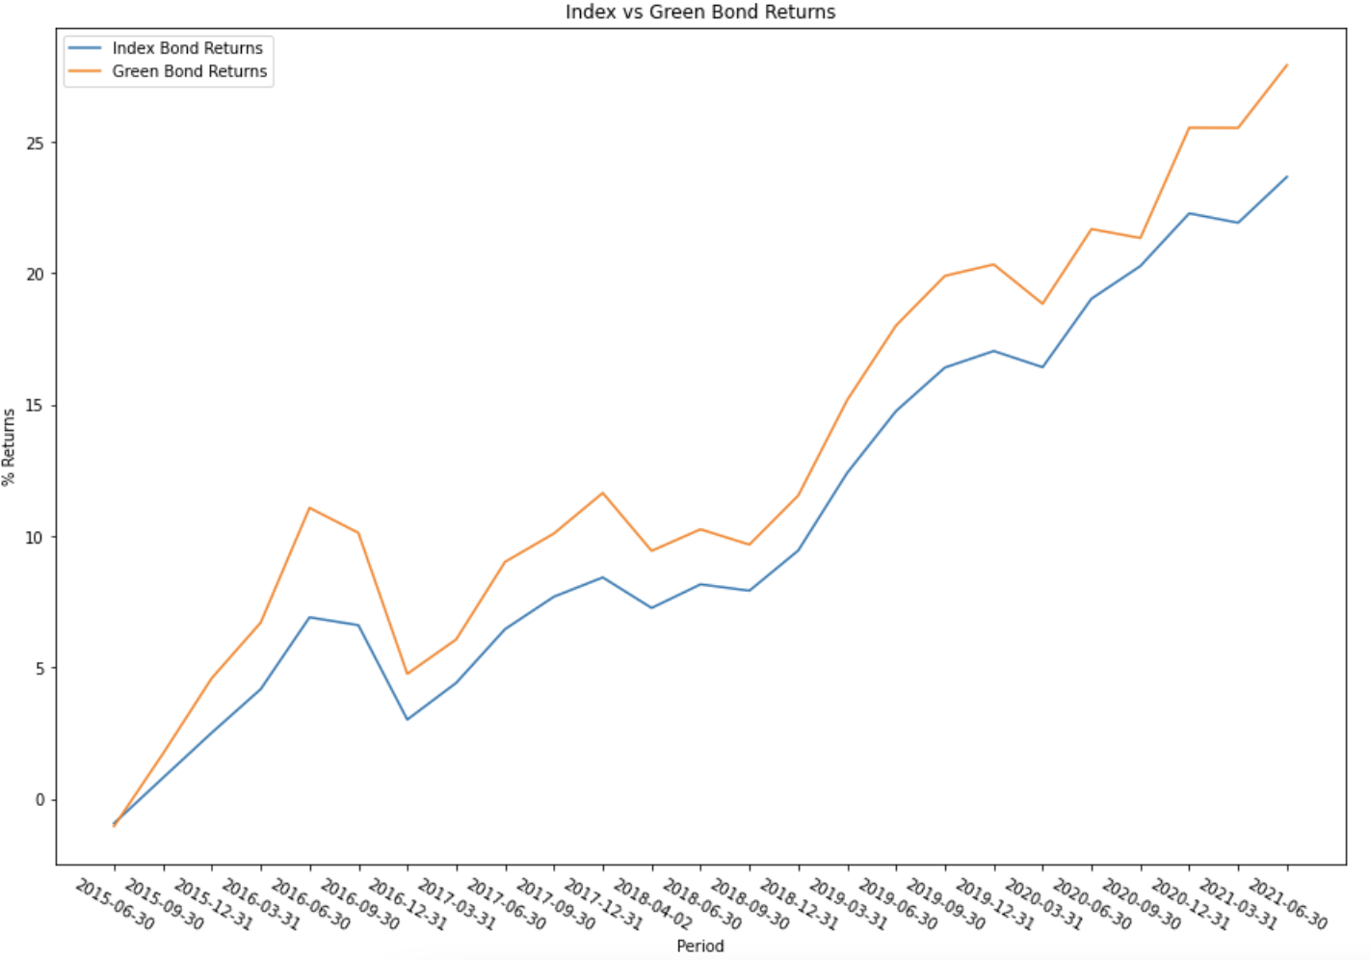

Figure :Chart shows that Green Bonds are performing better than normal index when adjusted for weights

Only Issue is that weight of green bonds is very less in comparison to total Index, hence we cannot make a proper conclusion just by seeing the plots.

There are two approaches to solve this problem:

1. Dealing with Imbalanced dataset
2. Working with Issuer level dataset

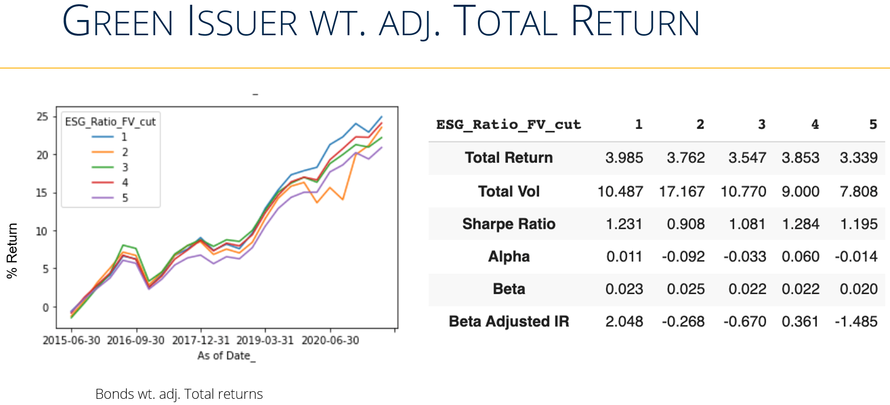

Issuer with any Green labelled bonds for a particular date is a Green Issuer for that date

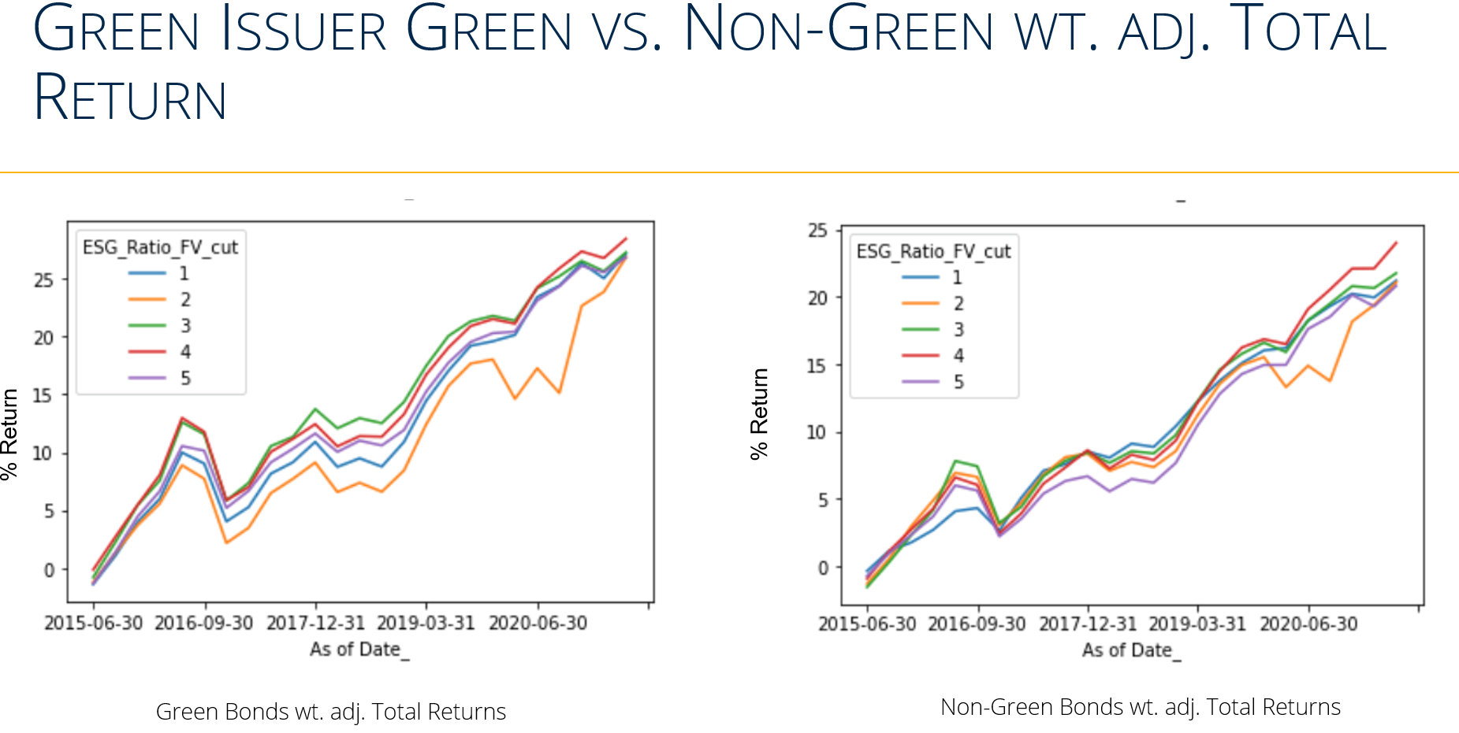

Issuer with any Green labelled bonds for a particular date is a Green Issuer for that date. First Green Issuer Bonds are divided into 5 quantiles then we check wt. adj. returns of Green vs Non-Green Bonds

Difference of Green vs Non-Green Bonds wt. adj. Excess Return

* Little bit high variation in Non- Green vs Green Bonds in Sharpe ratios
* ESG and Non-ESG Bonds perform much better in quantile 1,3,5 from quantile 2, 4

**Regression**

ESG Bond Returns Regression Analysis on Index Excess Returns

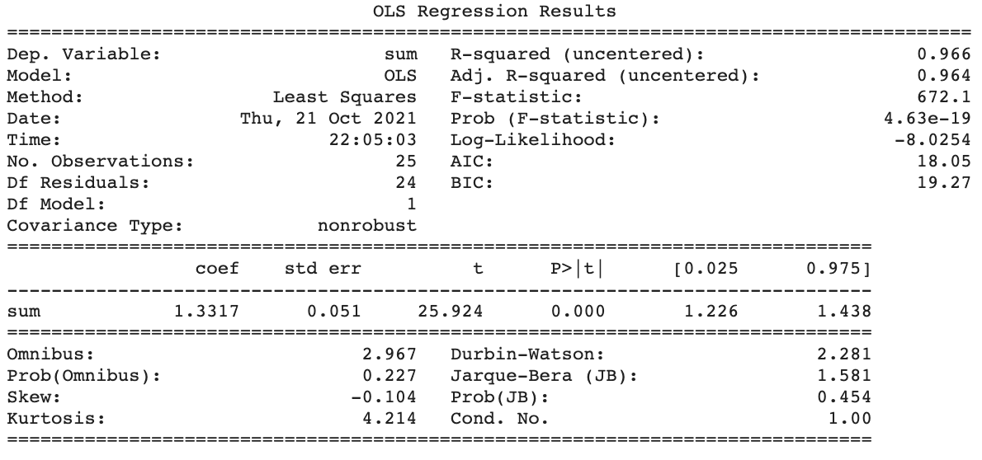 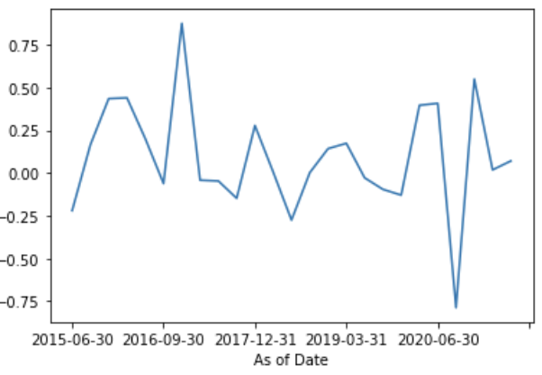

Regression Analysis with alpha constant on Index Excess Returns

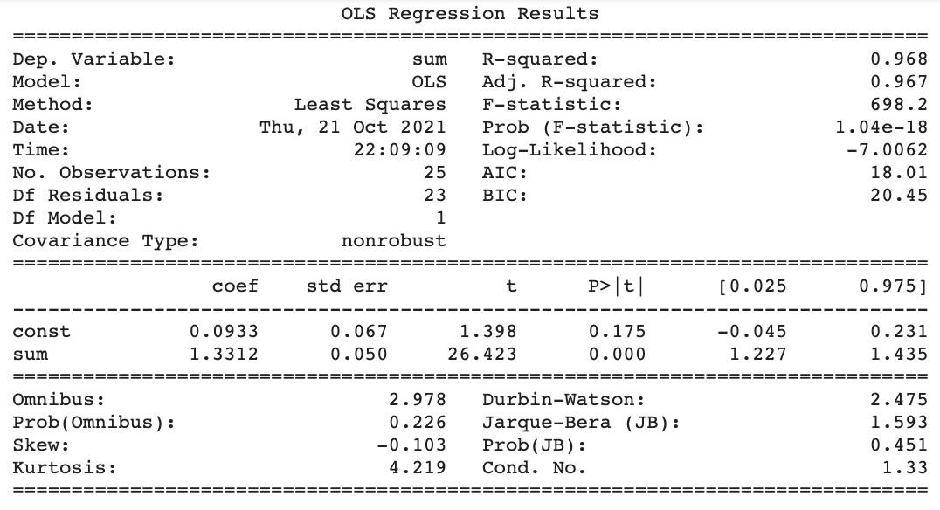

Non-ESG Bonds:

Bond Returns Regression Analysis on Index Excess Returns

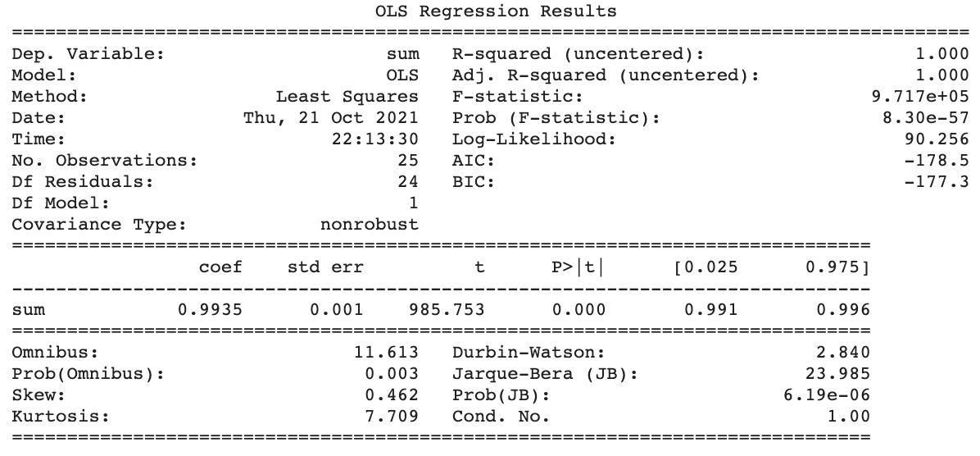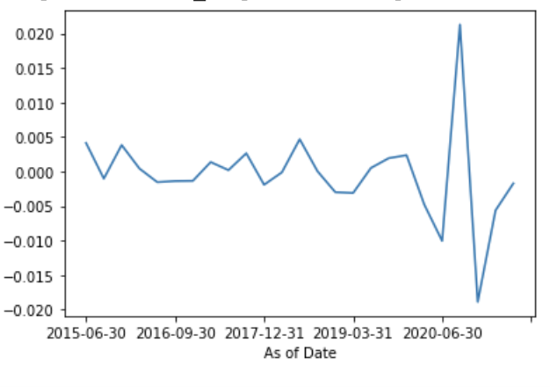

Regression Analysis with alpha constant on Index Excess Returns

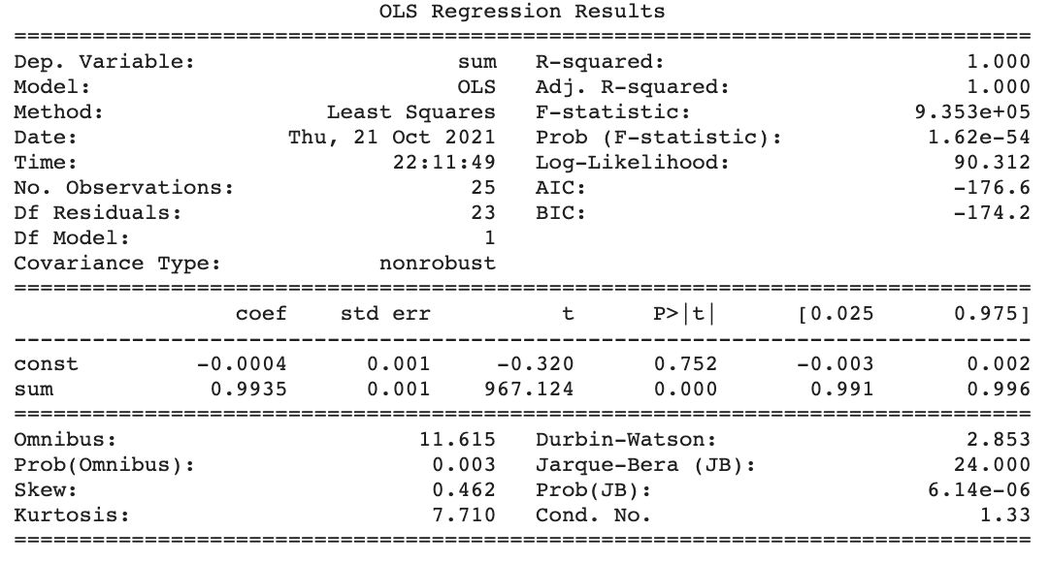

**Results**

The results are not great, our model learns from few parameters. This is probably because of two reasons:

* The data is too unbalanced towards the Non-Green Bonds. In the next iteration, I am going to use resampling of data to make it easier for the regression to learn in a balanced data.
* It is challenging to get the results using static parameters. Another way is to use momentum parameters like price change, %weight change as Input variables but we feel that might not be good intuitively.

**Final Discussion**

As basic differences can be seen in the charts in a comparable way, I am thinking of using regression to see if for each decile, we can see that difference of returns between Green vs Non-Green Bonds has no correlation to the factors which can explain the returns for the Green Bonds and Non-Green Bonds.

Main Factors Contributing to the returns of Municipal Bonds are:

* Duration to worst
* Yield to Worst

**Future Research**

* **More Data:** The way we get data could be biased. This area requires time and computational effort. We need to work with those indexes which has more coverage of Green bonds hence, making the comparison between quantiles will be more beneficial. Also, we need daily returns data to compute measures effectively.
* **More Relevant ESG Impact Valuation Metrics:** Setting some standards by creating framework across different Industries. Next, we will build create a framework to test whether these signals drive better social outcomes.

**Additional Data Sources**

**Environmental Metrics:**

* **Air Factors:** Air Pollution level Index, CO2 emissions, All pollutants emission (NO2, O3 etc.)
* **Water Factors:** Flood, Tsunami damage metric, High flood zone, Reduced Water Quality

**Social Metrics:**

* Land-Use and Biodiversity factors: Deforestation, Wildfire risks

**Governance Metrics:**

* Corporate Gender Ratio in Issuer
* Stakeholder activism

These factors divided either by revenue of the Issuer from these bonds or Face value for each bond can be a good metric to better classify these securities and create more efficient quantiles.

Appendix

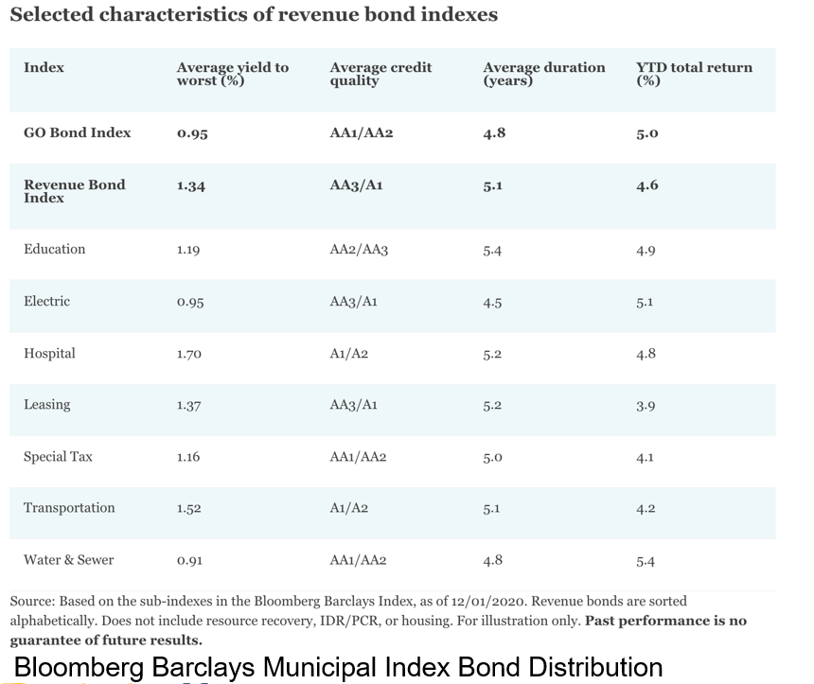

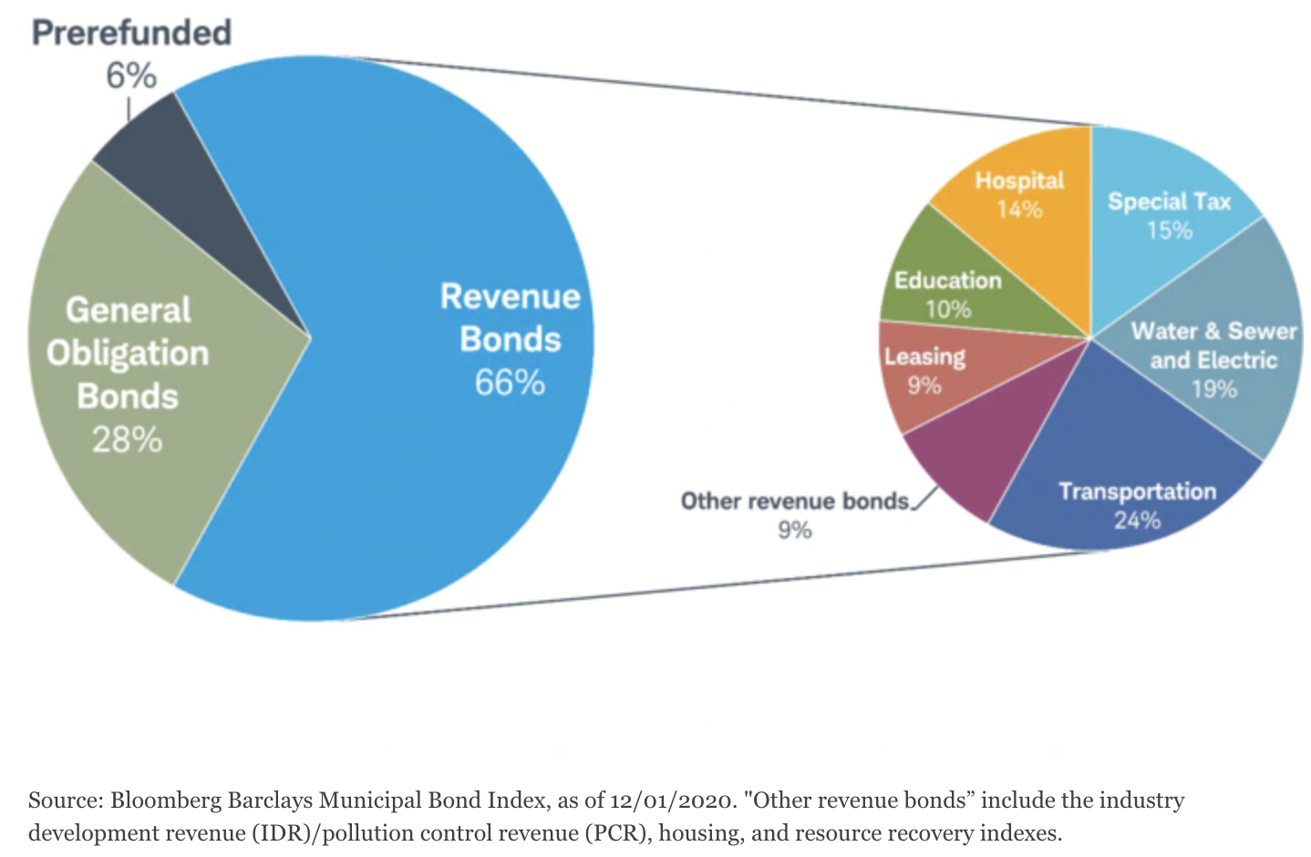

Bloomberg Barclays Municipal Index Bond Distribution

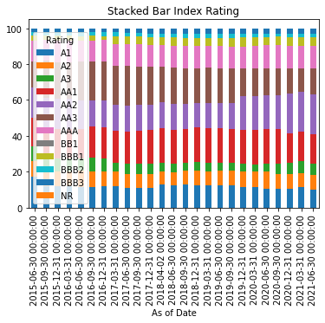 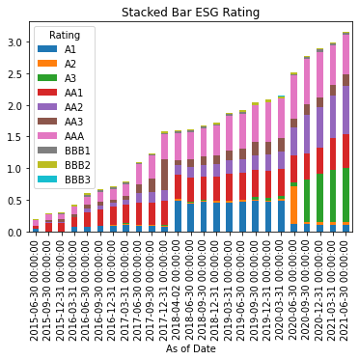

ICE Bonds

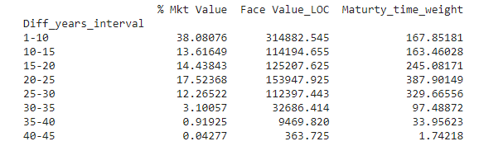

ESG Bonds

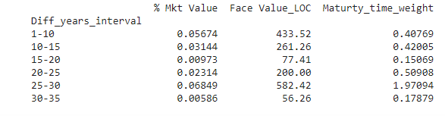

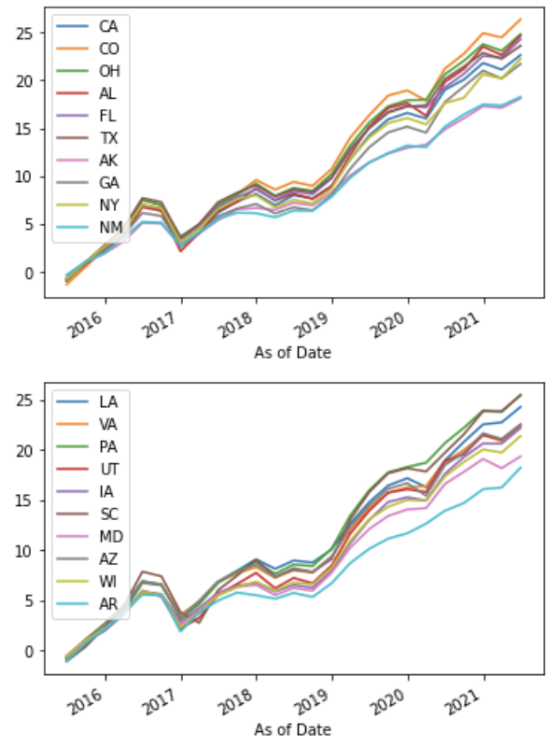 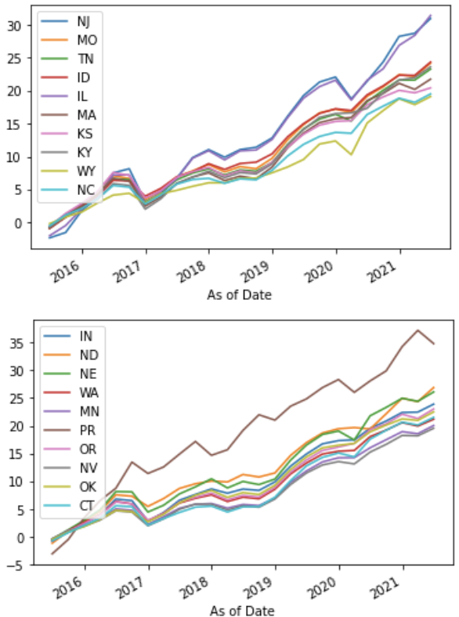 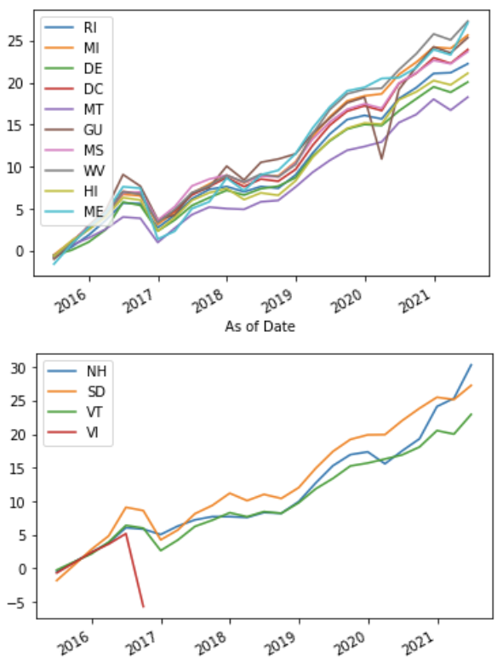

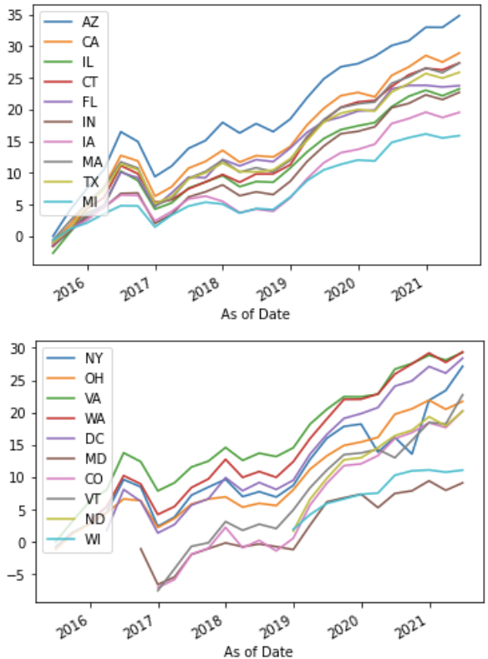 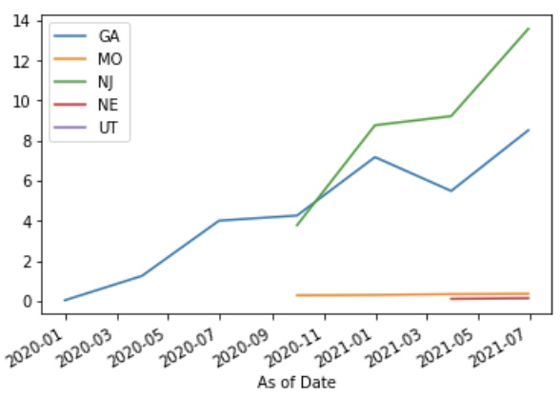

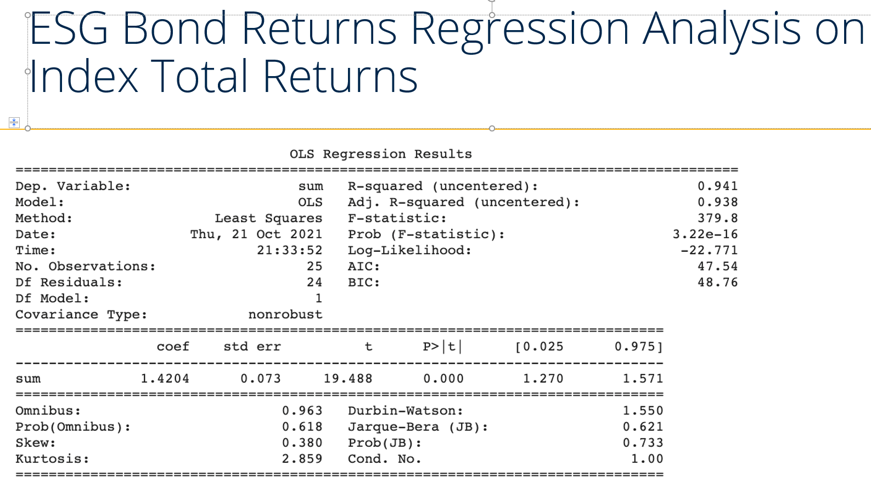 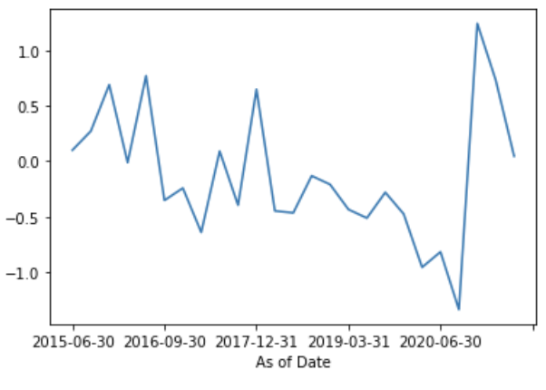

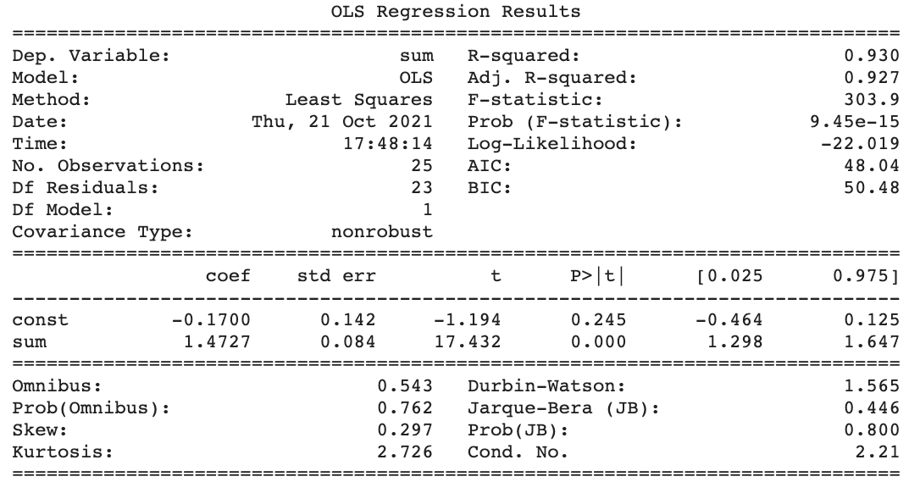

Bond Returns Regression Analysis on Index Total Returns

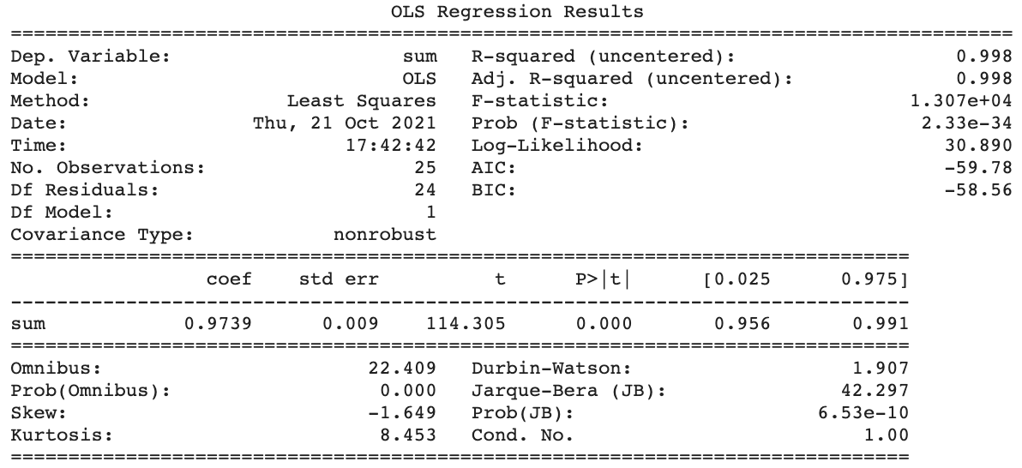 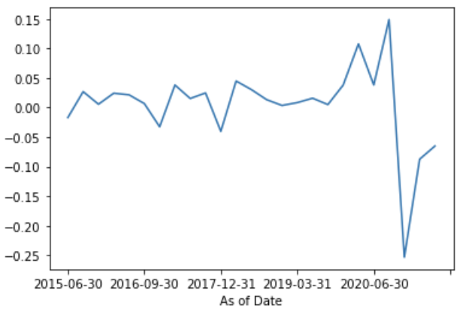

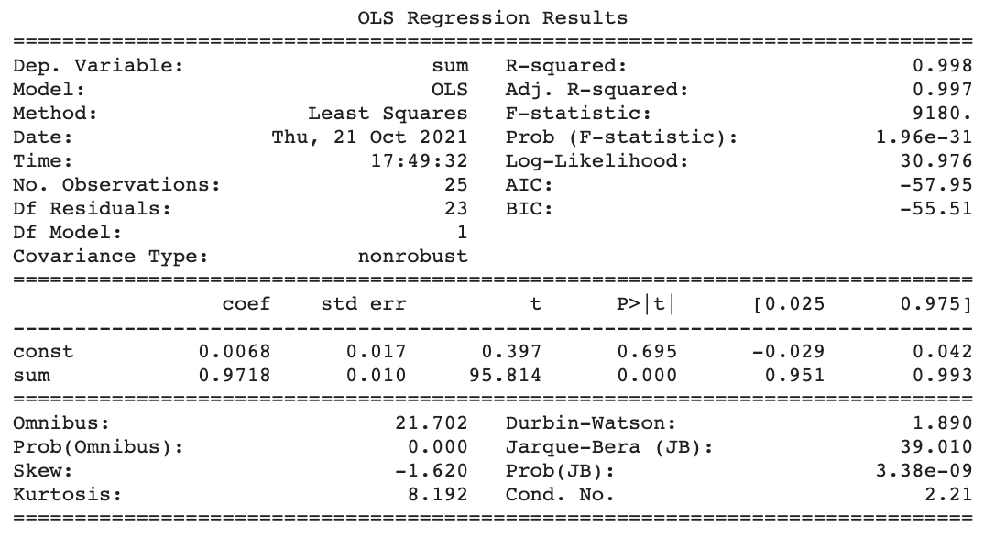

**Excess Returns:**

**ESG Data**

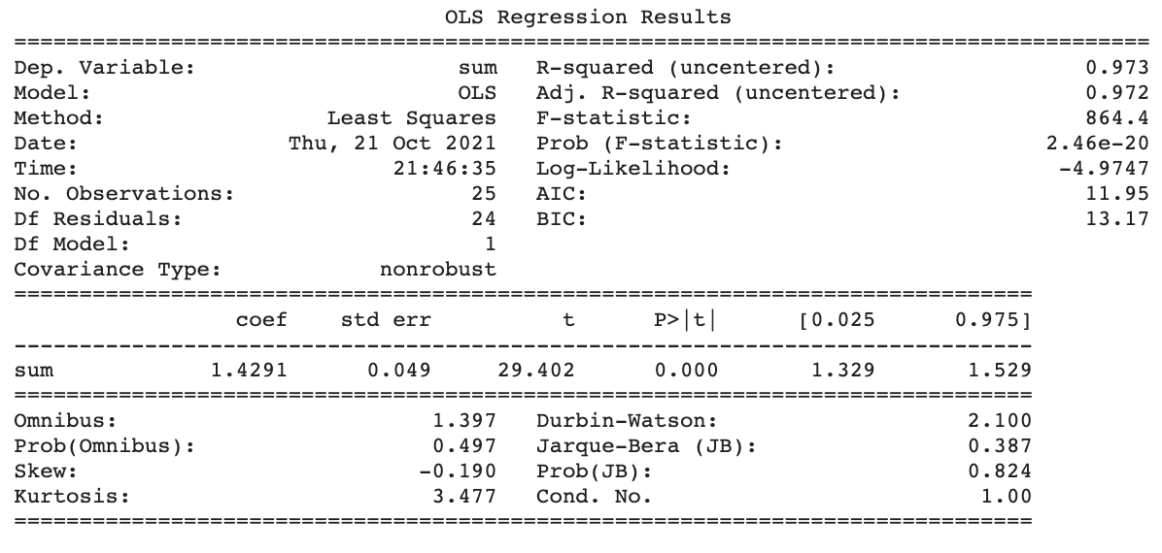 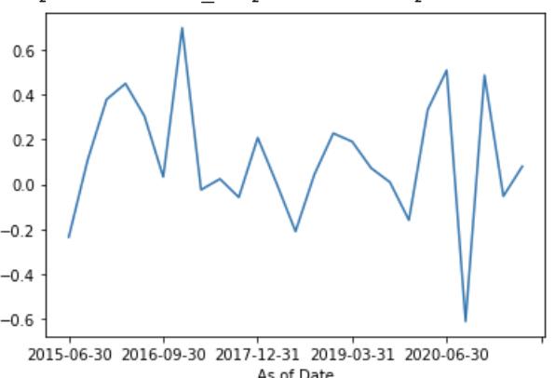

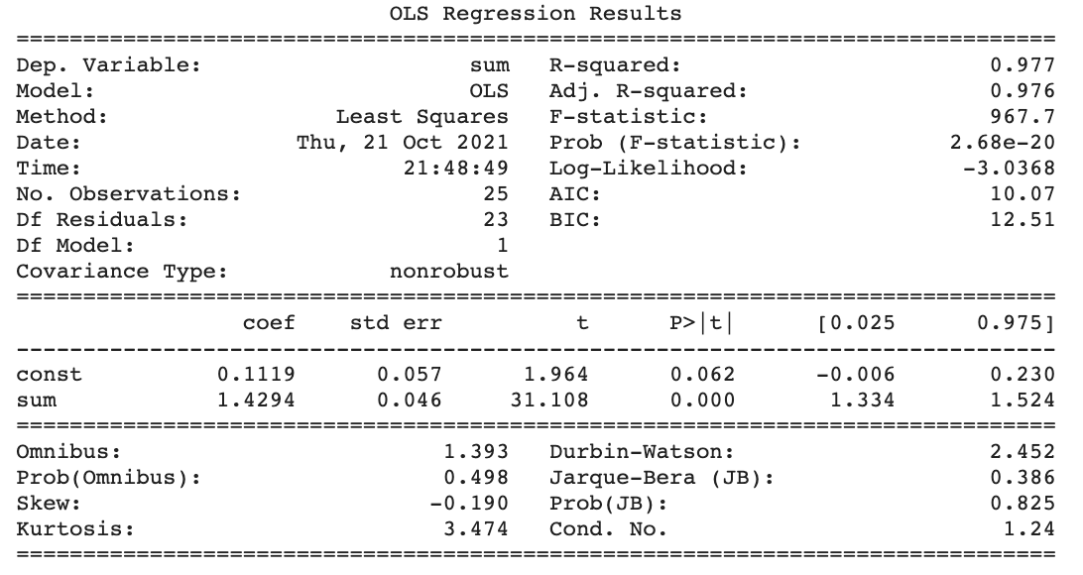

**Non-ESG Data:**

Bond Returns Regression Analysis on Index Total Returns

